PHOF

Text from 2019 JSNA - red = not yet updated

The number of births in West Sussex continues to fall, with 8,290 births in 2019, the lowest number since 2006 (ONS data - see embedded spreadsheet; includes some D&B specific data).
<<Births WS and D.Bs - ONS.xlsx>>

The infant mortality rate (E01, defined as the number of deaths in infants aged under 1 year per 1000 live births) in 2017-2019 was 3.5 per 1,000 live births (89 babies), similar to the national rate of 3.9 per 1,000, and a slight rise on the previous three years.

The neonatal mortality rate (defined as the number of deaths under 28 days, per 1,000 live births) has remained stable over the past 10 years, although saw a slight rise in 2017-2019, to 2.83 per 1,000 live births, in line with the England rate (2.86 per 1,000) and in the higher half of CIPFA neighbours.

In 2016-18, there were 83.5 premature births (less than 37 weeks gestation) per 1,000 live births and still births, increasing from a low of 76.6 per 1,000 in 2011-13, in line with the national rise (England rate 81.2 per 1,000).

The percentage of term babies with low birth weight (less than 2500g; C04) remains steady, at 2.32% in 2019, and significantly lower than England (2.9%) and in the lowest three of CIPFA neighbours.

The percentage of women smoking at the time of delivery (C06) remained low in 2019/2020, at 8.7% (approximately 678 maternities), compared with the national rate and was the second lowest of comparable authorities.

In 2018/19, 30.7% of births were by caesarean section in West Sussex. This proportion has been increasing over the last 5 years and is significantly higher compared with England (29.2%) and is the fourth highest of comparable authorities.

In 2019/2020, 90.5% of New Birth Visits (NBVs; C07) were completed within 14 days;
this has increased in recent years to be above the England rate (86.8%) and is in the higher half of comparable local authorities.

In 2019/2020, 57.7% of women breastfed (wholly or partly) at 6-8 weeks (C05b). Nationally, the figure was 48% (WS second highest of comparable authorities).

86.5% of children assessed achieved a good level of development at 2-2½
years [6], comparing well with England (84.1%), and making West Sussex the
fifth highest amongst comparable local authorities.

Uptake of the flu vaccine in 2-3 year-olds [7] has increased in recent years and
is higher than England (44.9%), but, at 48.9% in 2018/19, remains significantly
below the ≥65% benchmark
Infant and maternal health - infant mortality, birthweight, breastfeeding, maternal smoking
31 March 2021
13:57

Why is this subject important for health and wellbeing?

Infant health reflects the health of the population - and indicates the future health needs of the population as babies grow into children and adults and age in later life. Infant mortality, in particular, acts as a mirror for the effects on our health of our economic, social and environmental conditions - the so called "wider determinants of health".

Deaths occurring during the first 28 days of life (the neonatal period) in particular, are considered to reflect the health and care of both mother and newborn.

All infants and their families are eligible to receive a visit led by a health visitor within the first two weeks from birth (the New Birth Visit (NBV)), as part of the Healthy Child Programme (HCP). NBVs allow the early identification of problems in both infant and mother and provide support for important aspects of infant health and growth, including support with breast feeding.

On smoking, from PHOF:

There is substantial evidence that smoking during pregnancy and exposure to second-hand-smoke can lead to premature birth² among many other adverse health effects including complications during labour, low birth-weight at full term and increased risk of miscarriage and stillbirth.

Who is affected? Are some people more at risk than others? Does this vary across areas?

All mothers and infants. Poorer outcomes in more deprived people

Are there interventions to tackle the problem that are known to be effective? Is anything being done in West Sussex?
Also, what do we know at sub-county level, e.g. Ds&Bs, PCNs

Smokefree West Sussex Action plan - several actions in this relating to smoking during pregnancy

From <https://sfws-action-plan.netlify.app/>

How is it measured?
(Where possible include scale within the county)

What is the direction of travel?

Sources
Also note any gaps in knowledge

Key reports
(PHE reports, key and recent evidence)

Teenage pregnancy rate
31 March 2021
13:58

Why is this subject important for health and wellbeing?

Teenage mums will likely place greater demands on health and social services, they are more likely to have their baby removed….some may be ill-prepared for pregnancy/birth/parenthood…More likely to conceal their pregnancy

Children born to teenage mothers have 60% higher rates of infant mortality and are at increased risk of low birthweight which impacts on the child's long-term health. Teenage mothers are three times more likely to suffer from post-natal depression and experience poor mental health for up to three years after the birth. Teenage parents and their children are at increased risk of living in poverty.

Who is affected?

Women under 20, having unprotected sex, their partners and families

Are some people more at risk than others? Does this vary across areas?

Women under 20!!

How is it measured?
(Where possible include scale within the county)

What is the direction of travel?

https://fingertips.phe.org.uk/profile/child-health-profiles/data#page/1/gid/1938133225/pat/6/par/E12000008/ati/302/are/E10000032/cid/4/tbm/1

Decreased for 11 years running to 2018
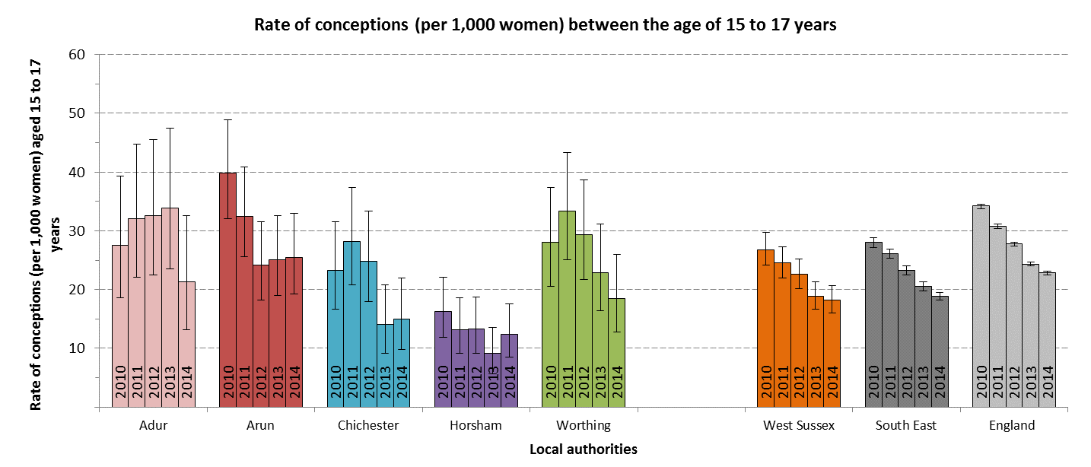
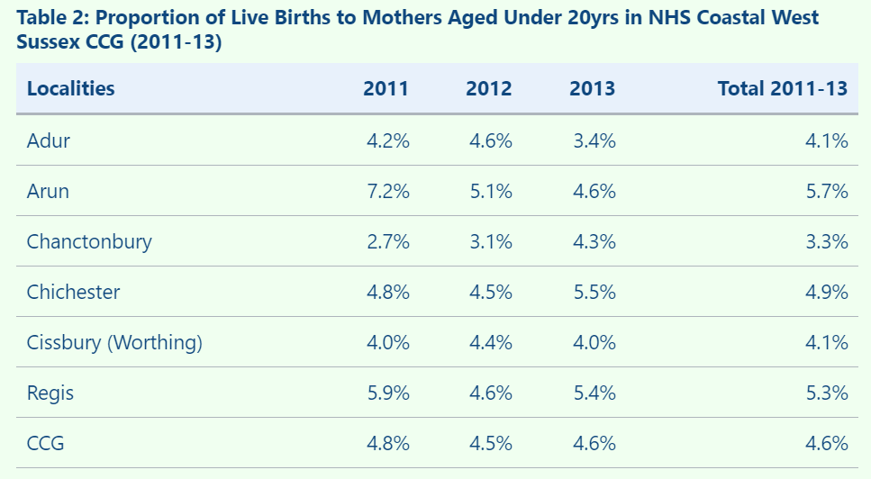
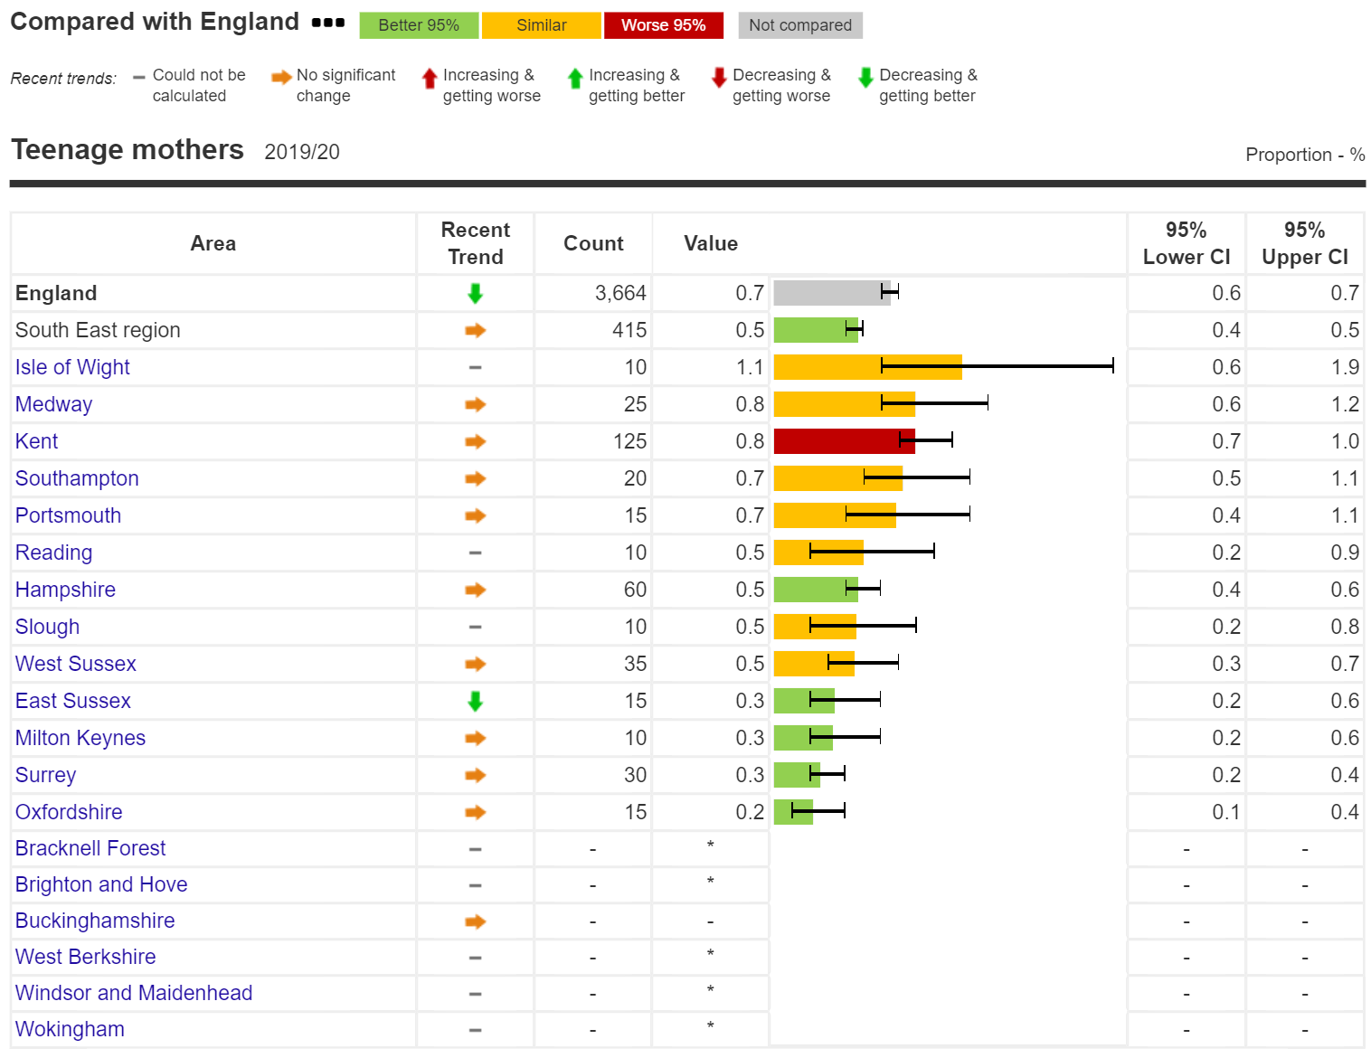

Are there interventions to tackle the problem that are known to be effective? Is anything being done in West Sussex?
Also, what do we know at sub-county level, e.g. Ds&Bs, PCNs

Family nurse partnership
https://fnp.nhs.uk/

Early help service
https://www.westsussex.gov.uk/social-care-and-health/social-care-and-health-information-for-professionals/children/early-help/support-from-pregnancy-to-2-years-old/

Teenage Pregnancy Prevention Framework
https://assets.publishing.service.gov.uk/government/uploads/system/uploads/attachment_data/file/836597/Teenage_Pregnancy_Prevention_Framework.pdf

RSE as part of PHSE in schools

Sources
Also note any gaps in knowledge

https://fingertips.phe.org.uk/profile/child-health-profiles/data#page/1/gid/1938133225/pat/6/par/E12000008/ati/302/are/E10000032/cid/4/tbm/1

Key reports
(PHE reports, key and recent evidence)

https://www.nhs.uk/pregnancy/support/teenage-pregnancy/

https://www.gov.uk/government/collections/teenage-pregnancy

Maternity Services - quality, location of births and choice
31 March 2021
13:58

Why is this subject important for health and wellbeing?

**effect on COVID-19 on provision of services - many antenatal appointments were conducted via phone/video calls (RW, TM and CW did a thematic analysis of responses to a survey on maternity services (incl. Family Assist) for the NHS - are the findings of this the kind of thing that could be referenced in the JSNA? NHS data though, I think…)

Who is affected?

Are some people more at risk than others? Does this vary across areas?

How is it measured?
(Where possible include scale within the county)

What is the direction of travel?

Are there interventions to tackle the problem that are known to be effective? Is anything being done in West Sussex?
Also, what do we know at sub-county level, e.g. Ds&Bs, PCNs

Sources
Also note any gaps in knowledge

https://digital.nhs.uk/data-and-information/data-collections-and-data-sets/data-sets/maternity-services-data-set

Key reports
(PHE reports, key and recent evidence)

Maternal mental health
31 March 2021
13:58

Why is this subject important for health and wellbeing?
Perinatal mental illnesses are a major public health issue that must be taken seriously. If untreated, these illnesses can have a devastating impact on women and their families. They are one of the leading causes of death for mothers during pregnancy and the year after birth.

Worldwide about 10% of pregnant women and 13% of women who have just given birth experience a mental disorder, primarily depression. In developing countries this is even higher, i.e. 15.6% during pregnancy and 19.8% after child birth. In severe cases mothers’ suffering might be so severe that they may even commit suicide. In addition, the affected mothers cannot function properly. As a result, the children’s growth and development may be negatively affected as well. Maternal mental disorders are treatable. Effective interventions can be delivered even by well-trained non-specialist health providers.

From <https://www.who.int/teams/mental-health-and-substance-use/maternal-mental-health>

Who is affected?
Mothers, families, education system, social services

Are some people more at risk than others? Does this vary across areas?
More likely to develop PND if already experienced anxiety and depression during pregnancy
Lack of partner/support network
Unplanned/unwanted pregnancy
Present/past pregnancy complications

How is it measured?
(Where possible include scale within the county)

What is the direction of travel?
Rates of PTSD post childbirth, costs on public sector and wider society, Depression (recorded prevalence), stillbirth rate, infant mortality rate

Are there interventions to tackle the problem that are known to be effective? Is anything being done in West Sussex?
Also, what do we know at sub-county level, e.g. Ds&Bs, PCNs
Maternal Mental Health Alliance
Increasing the availability of specialist PMH community care for women who need ongoing support from 12 months after birth to 24 months
Improving access to evidence-based psychological therapies for women and their partners
Mental health checks for partners of those accessing specialist PMH community services and signposting to support as required.
https://www.longtermplan.nhs.uk/wp-content/uploads/2019/07/nhs-mental-health-implementation-plan-2019-20-2023-24.pdf

Sources
Also note any gaps in knowledge

https://www.england.nhs.uk/mental-health/perinatal/
https://maternalmentalhealthalliance.org/
https://www.nspcc.org.uk/about-us/news-opinion/2019/fight-for-a-fair-start/
http://eprints.lse.ac.uk/59885/1/__lse.ac.uk_storage_LIBRARY_Secondary_libfile_shared_repository_Content_Bauer%2C%20M_Bauer_Costs_perinatal_%20mental_2014_Bauer_Costs_perinatal_mental_2014_author.pdf

Key reports
(PHE reports, key and recent evidence)
http://eprints.lse.ac.uk/59885/1/__lse.ac.uk_storage_LIBRARY_Secondary_libfile_shared_repository_Content_Bauer%2C%20M_Bauer_Costs_perinatal_%20mental_2014_Bauer_Costs_perinatal_mental_2014_author.pdf

Childhood Imms and Screening
31 March 2021
13:58

Why is this subject important for health and wellbeing?

**effect of COVID-19 on provision and take-up - obvious in HPV vaccines!

Colours = compared to benchmark (green is better, yellow is similar, red is worse)

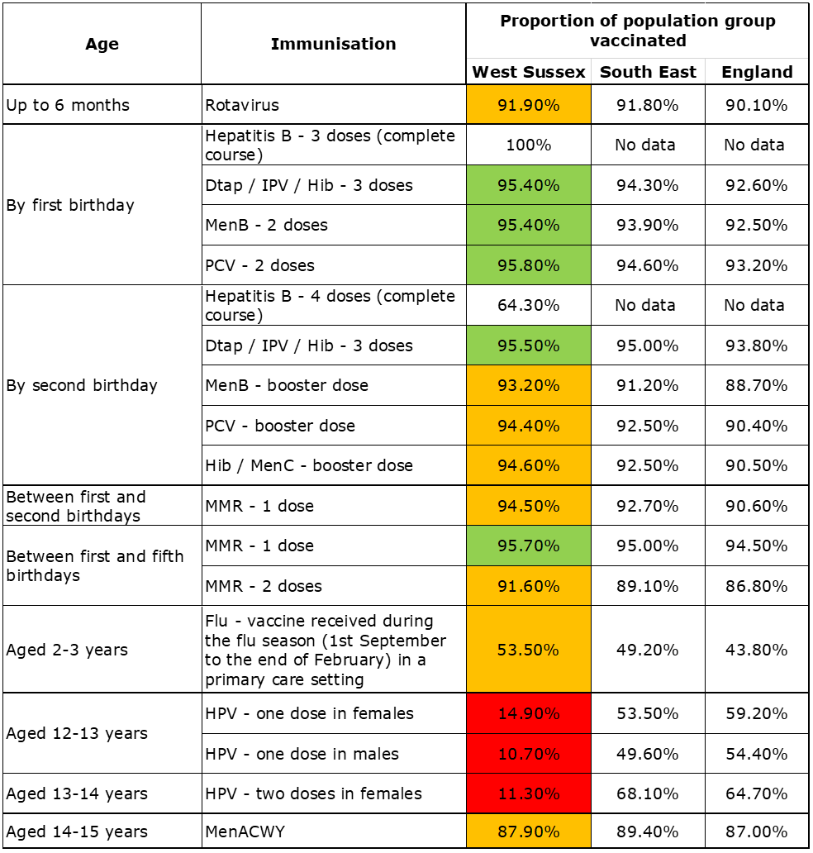

Who is affected?

Are some people more at risk than others? Does this vary across areas?

How is it measured?
(Where possible include scale within the county)

What is the direction of travel?

Are there interventions to tackle the problem that are known to be effective? Is anything being done in West Sussex?
Also, what do we know at sub-county level, e.g. Ds&Bs, PCNs

Sources
Also note any gaps in knowledge

Key reports
(PHE reports, key and recent evidence)

Hospital admissions & self-harm

Are there interventions to tackle the problem that are known to be effective? Is anything being done in West Sussex?
Also, what do we know at sub-county level, e.g. Ds&Bs, PCNs
31 March 2021
13:58

Who is affected? Are some people more at risk than others? Does this vary across areas?

VP's data (at bottom of page) includes self-harm data broken down to D&B level

Hospital admissions caused by unintentional and deliberate injuries in young people (C11)

Injuries are a leading cause of hospitalisation and represent a major cause of premature mortality for children and young people. They are also a source of long-term health issues, including mental health related to experience(s).

West Sussex compares poorly to similar local authorities, particularly for admissions in young people aged 15-24. Admissions have been decreasing in 0-14 year olds in recent years, yet admissions in 15-24 years remain high.

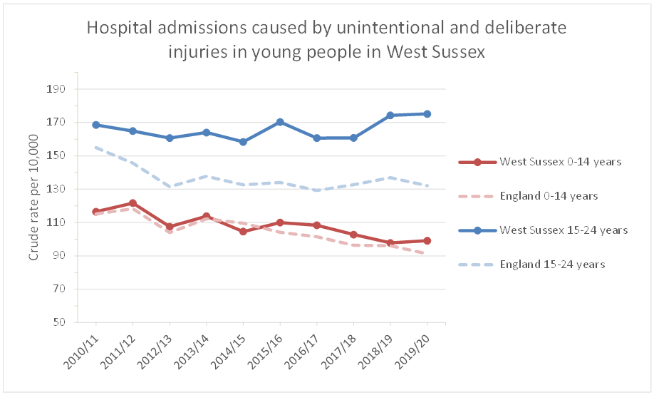
Self-harm

As described by the National Self-Harm Network,

"Self-harm can take many different forms and as an individual act is hard to define. However, in general, self-harm (also known as self-injury or self-mutilation) is the act of deliberately causing harm to oneself either by causing a physical injury, by putting oneself in dangerous situations, and/or self-neglect".

Data on hospital admissions as a result of self-harm are provided here, but this is a relatively limited view of the problem - self-harm that results in a hospital admission may be different in nature than self-harm that does not result in a hospital admission. It's also important to note that self-harm affects all ages, although self-harm behaviours often start in childhood and can persist into adulthood.

In West Sussex, hospital admissions as a result of self-harm are highest in young people aged 15-19, followed by 20-24 year olds, exceeding the national rates and comparing poorly to similar authorities for these ages.

In 2019/20, there were 125 admissions of 10-14 year olds, 415 admissions of 15-19 year olds and 320 admissions of 20-24 year olds.

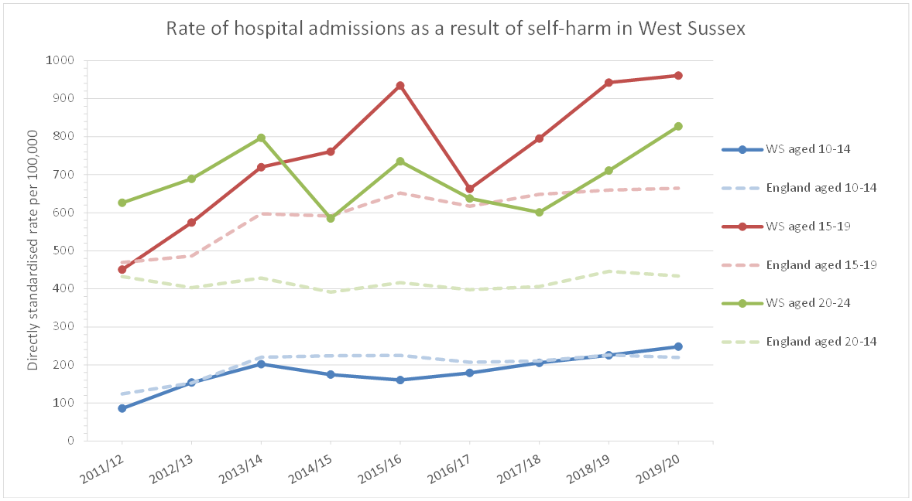

VP: Self-harm data for 2019/20 has now been released by PHE. The data in the doc here is marked provisional, but I think I got the same rates as those published (although this doesn’t include comparison with England). I expect I will do some further work on self-harm in the coming months since it’s a local priority area – Rachel Jevons has done a lot of work on this topic with Dani.

<<Admissions_for_self_harm_10to24s_2019-20_Provisional_Rates v2.docx>>

How is it measured?
(Where possible include scale within the county)

What is the direction of travel?

Key reports
(PHE reports, key and recent evidence)

Sources
Also note any gaps in knowledge

CYP - Summary of the ONS report: Mental Health of Children and Young People in England, 2020: Wave 1 follow up to the 2017 survey'
31 March 2021
13:58
<<CYP Mental Health 2017 to 2020 ONS report summary.docx>>
**Things included in this ONS report to see if we have WS data on**
  - Children with parents WFH; working more hours or having taken on additional work; and furloughed or made use of the self-employed support scheme.
  - School attendance (key worker parents; vulnerable; other reasons) and return (either on a full or part time basis)
  - Use of food banks

Why is this subject important for health and wellbeing?

This is a big COVID-affected one - although the effects on children's mental health are not uniform; some children will have suffered greatly during the pandemic whilst others will have experienced no declines in mental wellbeing and others may even have thrived under the conditions.

BMJ summary article: Mental health of children and young people during pandemic (March 2021) <https://www.bmj.com/content/372/bmj.n614>

*previous JSNA has PHE’s 2015 estimates of the prevalence of MH conditions in CYP for WS – is there an update on this? 6 years old now and a lot has changed, incl. population demographics. Do we want to include this anyway?
Content from the linked document, summarising the 'Mental Health of Children and Young People in England, 2020: Wave 1 follow up to the 2017 survey' (https://digital.nhs.uk/data-and-information/publications/statistical/mental-health-of-children-and-young-people-in-england/2020-wave-1-follow-up). This can be presented much better than a block of text - but need to see how the website is going to look first:
Major national surveys remain the best source of evidence on the prevalence of mental health disorders among children and young people
In 2020, the ONS published the first in a series of reports that follow up on the mental health of 3570 children and young people who participated in the 2017 Mental Health and Young People Survey (MHCYP). Conducted via online surveys in July 2020, this report provides insight into the mental health effects of the COVID-19 pandemic and how the mental health of children and young people has changed since 2017.
Prevalence of probable mental disorders (PMD) – Rates of PMD have increased from 1 in 9 children aged 5-16 years in 2017 to 1 in 6 in 2020. This is evident in for both sexes.
- The likelihood of a PMD increases with age. In 17-22 year olds, there is a noticeable difference between genders, at 27.2% of young women compared to 13.3% of young men.
- The proportion of children aged 5-16 years of White ethnic backgrounds with a PMD has increased since 2017 and is more than double that of children of BAME backgrounds (18.8% vs. 7.5%)
- By neighbourhood-level deprivation, there was no significant difference in the presence of PMD in children aged 5-16 years between 2017 and 2020.
Wellbeing during the pandemic – Children and young people with a PMD were more likely to report reduced wellbeing during the pandemic, such sleep problems, loneliness and feeling that lockdown had made their life worse, and to have engaged in health risk behaviours.
- More than 1 in 4 of those aged 5-22 years reported sleep problems, with this being more common in girls than boys and in those aged 17-22 years. For all ages, more than double the number of children with a PMD reported sleep problems than those unlikely to have a PMD.
- 1 in 10 of those aged 11-22 years said that they often or always felt lonely. This was more common in girls, those aged 17-22 years and in those with a PMD
- Around 4 in 10 of those aged 11-22 years who were unlikely to have a PMD said that lockdown had made their life worse. This rose to over half of 11-22 years with a PMD (increasingly slightly with age)
- More of those aged 17-22 years with a PMD reported engaging in health risk behaviours, with around 1 in 5 smoking cigarettes (vs. 1 in 20 unlikely to have a mental disorder) and 1 in 10 used cannabis or other drugs (vs. fewer than 1 in 50 unlikely to have a mental disorder).
- Children with a PMD were also more likely to have a parent who thought that their child was worried about themselves or family/friends catching COVID-19, leaving the house or spreading COVID-19 than those unlikely to have a mental disorder
Family circumstances and dynamics – children with a PMD were more likely to have experienced family problems than those unlikely to have a mental disorder:
- Around 1 in 6 of children aged 5-16 years with a PMD were living in a household that had fallen behind with payments (vs. around 1 in 20 of those unlikely to have a mental disorder).
- Nearly 1 in 3 children with a PMD were living in a family who reported problems with family functioning (vs. around 1 in 10 children unlikely to have a mental disorder)
- Nearly two thirds of girls aged 11-16 years with a PMD had seen or heard an argument among adults in the household, compared to a little under half of those unlikely to have a mental disorder.

Access to mental health services and school support during March/April-July 2020
- Young people aged 17 to 22 years old were more likely than younger children to have sought but not received help for mental health problems (7.4% vs. 3.8%).
- Around 1 in 5 young people aged 17-22 year with a PMD decided themselves not to seek help for a mental health concern. This was less common for the parents of younger children, 1 in 12 of whom decided not to seek help for a concern around their child’s mental health.
- Around 6 in 10 children aged 5-16 years with a PMD had regular support from their school or college during the summer school term, compared with over three quarters of children unlikely to have a mental disorder

Who is affected?

Are there interventions to tackle the problem that are known to be effective? Is anything being done in West Sussex?
Also, what do we know at sub-county level, e.g. Ds&Bs, PCNs

How is it measured?
(Where possible include scale within the county)

What is the direction of travel?

Are some people more at risk than others? Does this vary across areas?

Sources
Also note any gaps in knowledge

Key reports
(PHE reports, key and recent evidence)

CYP Mental Health - Tiers Assumptions - could we just copy over the previous JSNA's figures? How were these calculated? Do we have more up to date figures?
29 June 2021
12:08

Why is this subject important for health and wellbeing?

From JSNA 2019:

Mental health services are often described in terms of tiers, where services become more specialised, from emotional wellbeing services at Tier 1 to highly specialist outpatient teams and inpatient provision at Tier 4. [includes pyramid of tiers]

Prevalence estimates (population aged 17 and under) based on findings published in “Treating Children Well” [1]
are shown below against each of the tiers. These provide an estimate of West Sussex CYP who may at any one time, need a service response or support.
[1] Kurtz, Z. (1996) Treating children well: a guide to using the evidence base in commissioning and managing services for the mental health of children and young people. London. Mental Health Foundation.

Who is affected?

Are some people more at risk than others? Does this vary across areas?

How is it measured?
(Where possible include scale within the county)

What is the direction of travel?

Are there interventions to tackle the problem that are known to be effective? Is anything being done in West Sussex?
Also, what do we know at sub-county level, e.g. Ds&Bs, PCNs

Sources
Also note any gaps in knowledge

Key reports
(PHE reports, key and recent evidence)

CYP - Autism
31 March 2021
13:58

Why is this subject important for health and wellbeing?

Who is affected?

Are some people more at risk than others? Does this vary across areas?

How is it measured?
(Where possible include scale within the county)

What is the direction of travel?

Are there interventions to tackle the problem that are known to be effective? Is anything being done in West Sussex?
Also, what do we know at sub-county level, e.g. Ds&Bs, PCNs

Sources
Also note any gaps in knowledge

Key reports
(PHE reports, key and recent evidence)

CYP with disabilities, access to services and support
31 March 2021
13:58

Why is this subject important for health and wellbeing?

Who is affected?

Are some people more at risk than others? Does this vary across areas?

How is it measured?
(Where possible include scale within the county)

What is the direction of travel?

Are there interventions to tackle the problem that are known to be effective? Is anything being done in West Sussex?
Also, what do we know at sub-county level, e.g. Ds&Bs, PCNs

Sources
Also note any gaps in knowledge

Key reports
(PHE reports, key and recent evidence)

Oral health of children
31 March 2021
13:58

Why is this subject important for health and wellbeing?

Oral health is an important part of overall health and dental decay is largely a preventable disease. However, its prevalence nationally remains high and is greater in children from deprived areas and is variable amongst different ethnic groups. Poor oral health in children remains an important public health issue - with consequences that may extend beyond pain and distress, such as sleepless nights for children and parents, and time off school and work - and can be viewed as an indicator of related health issues such as children's weight and diet.

Key reports
(PHE reports, key and recent evidence)

Whilst West Sussex lower tier local authorities didn't participate in the most recent 2018/19 oral health survey of 5 year olds, the proportion of 5 year olds with experience of visually obvious dental decay, at 15.1%, was below that of the South East region and England in the previous 2016/17 survey.

There were 155 hospital admissions for dental caries in 0-5 year olds in 2017/18-2019/20, equivalent to a rate of 90.8 per 100,000.

Why didn't West Sussex LTLAs participate in the Dental Public Health Epidemiology Programme for England: oral health survey of five-year-old children 2019? (https://assets.publishing.service.gov.uk/government/uploads/system/uploads/attachment_data/file/873492/NDEP_for_England_OH_Survey_5yr_2019_v1.0.pdf)

Who is affected?

Are some people more at risk than others? Does this vary across areas?

How is it measured?
(Where possible include scale within the county)

What is the direction of travel?

Are there interventions to tackle the problem that are known to be effective? Is anything being done in West Sussex?
Also, what do we know at sub-county level, e.g. Ds&Bs, PCNs

Sources
Also note any gaps in knowledge

Healthy weight
31 March 2021
13:58

Why is this subject important for health and wellbeing?

Who is affected?

Are some people more at risk than others? Does this vary across areas?

How is it measured?
(Where possible include scale within the county)

What is the direction of travel?

Are there interventions to tackle the problem that are known to be effective? Is anything being done in West Sussex?
Also, what do we know at sub-county level, e.g. Ds&Bs, PCNs

Sources
Also note any gaps in knowledge

Key reports
(PHE reports, key and recent evidence)

https://www.gov.uk/government/statistics/national-child-measurement-programme-ncmp-trends-in-child-bmi/ncmp-trends-in-childrens-bmi-between-2006-to-2007-and-2019-to-2020

VP: Some recent analysis on NCMP results for year R and year 6 in the NCMP 201920.docx. This is not a "complete" analysis and further work could (and should) be done to look at inequalities in more detail...

<<NCMP 201920.docx>>

The folder below also includes outputs from Fingertips (fingertipsR package) using the 2019/20 data that can be lifted directly.
\\chi_nas_prod2.corporate.westsussex.gov.uk\groups2.bu\Public Health Directorate\PH Research Unit\Verity Pinkney\R\Output\NCMP\1920\

Previous summaries that could be useful include the HWP slides 29012020 – this uses data to 2018/19 (or 17/18 if ward level).
<<HWP slides 29012020.pdf>>

Exercise and physical activity
31 March 2021
13:58

Why is this subject important for health and wellbeing?

Who is affected?

Are some people more at risk than others? Does this vary across areas?

How is it measured?
(Where possible include scale within the county)

What is the direction of travel?

Are there interventions to tackle the problem that are known to be effective? Is anything being done in West Sussex?
Also, what do we know at sub-county level, e.g. Ds&Bs, PCNs

Sources
Also note any gaps in knowledge

Key reports
(PHE reports, key and recent evidence)

Sports facilities and assets
31 March 2021
13:58

Why is this subject important for health and wellbeing?

Who is affected?

Are some people more at risk than others? Does this vary across areas?

How is it measured?
(Where possible include scale within the county)

What is the direction of travel?

Are there interventions to tackle the problem that are known to be effective? Is anything being done in West Sussex?
Also, what do we know at sub-county level, e.g. Ds&Bs, PCNs

Sources
Also note any gaps in knowledge

Key reports
(PHE reports, key and recent evidence)

Smoking
31 March 2021
13:58

Why is this subject important for health and wellbeing?
Respiratory disease is one of the top causes of death in England in under 75s and smoking is the major cause of chronic obstructive pulmonary disease (COPD), one of the major respiratory diseases.
Tom Howell/Rob Whitehead did a survey on youth smoking - worth looking at?

Who is affected?

Smokers, secondhand smokers, health system

Are some people more at risk than others? Does this vary across areas?
To start smoking - those with parents or siblings who smoke are 3 times more likely to start smoking than those without
Those who start smoking at the youngest ages are more likely to smoke heavily and find it harder to give up.
Heavy smokers are at the greatest risk of developing smoking related diseases.

How is it measured?
(Where possible include scale within the county)

What is the direction of travel?

Are there interventions to tackle the problem that are known to be effective? Is anything being done in West Sussex?
Also, what do we know at sub-county level, e.g. Ds&Bs, PCNs
Pharmacotherapy support - NRTs, Champix, Zyban
Unlicensed NCPs (e-cig, vape etc)

• Patients who smoke experience worse clinical outcomes than people who have never smoked. Quitting smoking at the time of, or soon after, diagnosis improves disease outcomes
• Smokers with lung cancer automatically referred into a telephone-based smoking cessation service demonstrated a near doubling of survival
• Stop Smoking Services as a part of comprehensive tobacco control strategy across the county
• Smoking cessation reduces the rate of progression of COPD
• Smoking cessation after stroke or transient ischemic attack reduced the 5-year risk of stroke, myocardial infarction or death to 15.7% (from 22.6% among those who continued to smoke)

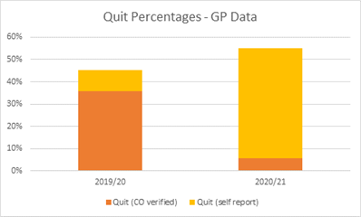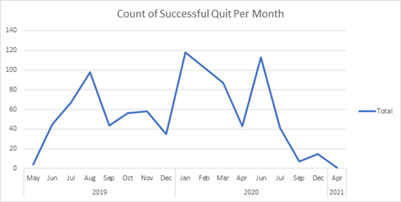

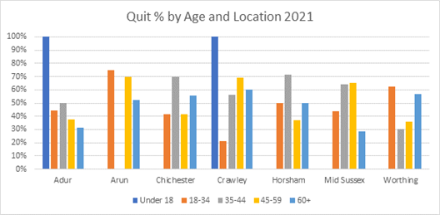
High quit success rates in under 18s (N.B. low numbers)
60+ quit rate was lowest in Mid Sussex
Very low quit success rate in 18-34 year olds in Crawley
No successful quits in 35-44 year olds in Arun

Sources
Also note any gaps in knowledge

Key reports
(PHE reports, key and recent evidence)
https://ash.org.uk/category/information-and-resources/young-people-tobacco-information-and-resources/#:~:text=Those%20whose%20parents%20or%20siblings,of%20developing%20smoking%20related%20diseases.

Substance Misuse
31 March 2021
13:58
Worth checking in with myself and Ally K when you get to this one, we could provide a case-study on the children of alcohol dependent parents project.

Other than that, main source would be WAY survey, and I think it was touched on in the Year 6 Health and Happiness Survey, although could be wrong.

Why is this subject important for health and wellbeing?

Who is affected?

Are some people more at risk than others? Does this vary across areas?

How is it measured?
(Where possible include scale within the county)

What is the direction of travel?

Are there interventions to tackle the problem that are known to be effective? Is anything being done in West Sussex?
Also, what do we know at sub-county level, e.g. Ds&Bs, PCNs

Sources
Also note any gaps in knowledge

Key reports
(PHE reports, key and recent evidence)

Child poverty
31 March 2021
13:58

Definitely seems like something we could ask for?

Why is this subject important for health and wellbeing?
Is Healthy Start voucher uptake data available? Oxford CC used it in their last JSNA but their link to the Healthy Start data page doesn't work…

Do we have data on free school meals? Both eligible and actually taking it up?

- Free school meals is definitely reported on - things will have been a bit different in the last year or so

Could include Family Assist data? Produce monthly service data (according to Graeme Potter)
VP:
Children in relative and absolute low income families
I did some work not that long ago for the Mental Health in Schools programme. This document provides a summary of deprivation indicators. This includes general IMD 2019 (there are better write-ups of this so you may want to ignore), and the absolute and relative measures of low income for CYP.

<<MHST_West_Sussex_16_03_2021.docx>>
Graph of relative and absolute low income families in WS to supplement VP's work:

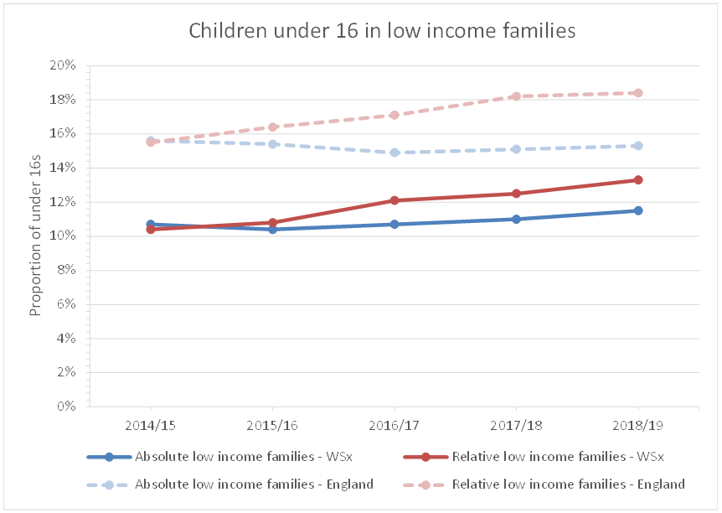

Slightly off topic, but Elective Home Education:
This document also provides numbers of children known to be home educated. This data was provided by Andrew Parker (Education and Skills) and we would need to confirm that we can use this publicly if we were to include in the JSNA (otherwise, some general sentences would suffice).

Regarding FSM:
Free school meals data is routinely published from the January school census – here:
https://explore-education-statistics.service.gov.uk/find-statistics/school-pupils-and-their-characteristics

However, I think there was an extra release during COVID for autumn term too – I don't know what geography but it may be of use:
https://explore-education-statistics.service.gov.uk/find-statistics/free-school-meals-autumn-term/2020-21-autumn-term

I have also received newer data on FSM from the Spring 2021 census (the most up to date that we could have an is ahead of that currently in the public domain) from Ian Rogers (sourced from Matt King). Again, we'd have to clear it's use and mark the % as provisional but it did raise some interesting questions about FSM eligibility during COVID.

The presentation below is FYI – and would need clearing with Matt King.
<<FSM by D&B Spring 2016 to Spring 2021.pptx>>

Who is affected?

Are some people more at risk than others? Does this vary across areas?

How is it measured?
(Where possible include scale within the county)

What is the direction of travel?

Are there interventions to tackle the problem that are known to be effective? Is anything being done in West Sussex?
Also, what do we know at sub-county level, e.g. Ds&Bs, PCNs

Sources
Also note any gaps in knowledge

Key reports
(PHE reports, key and recent evidence)

Children in homeless households, temp accommodation
31 March 2021
13:58

Why is this subject important for health and wellbeing?

Who is affected?

Are some people more at risk than others? Does this vary across areas?

How is it measured?
(Where possible include scale within the county)

What is the direction of travel?

Are there interventions to tackle the problem that are known to be effective? Is anything being done in West Sussex?
Also, what do we know at sub-county level, e.g. Ds&Bs, PCNs

Sources
Also note any gaps in knowledge

Key reports
(PHE reports, key and recent evidence)

Education - Early years provision, School Readiness, Attainment at key stages and progression to HE, pupil absence NEET, SEND
School Readiness and achievement throughout school (2019) - LAIT data

School readiness and achievement measures in West Sussex pupils are generally comparable to England. However, the proportion of pupils who are eligible for FSM who reach these achievements is consistently lower than the England proportion.

In recent years, previous increases seen in the proportions of all pupils and those eligible for FSM achieving a good level of development in Reception and the expected level in phonics decoding in Year 1 have stalled and plateaued. In contrast, achievement of the expected level of reading, writing and maths has generally increased for all pupils and those eligible for FSM since 2016, when the new curriculum was introduced into schools.

In line with England, the proportions of pupils achieving a Level 2 qualification by age 19 has seen a downward trend since 2015; this fall is most stark in pupils eligible for FSM, who have fallen from a high of 71.5% in 2014 to 60.3% in 2019.

I can't work out how to get the England dashes over the relevant bars 😭

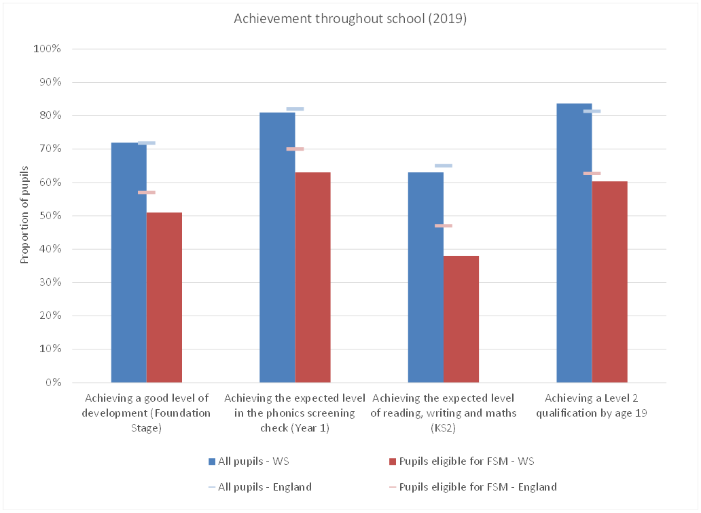

Progression to further Higher Education (HE)

37.9% of all pupils progressed to HE by age 19 in 2018/19. Far fewer pupils eligible for FSM - only 15% - progressed to HE. These proportions are below those of England and comparable local authorities.

Data from the Office of Students TUNDRA tool shows around a fifth of West Sussex's LSOAs are ranked in the lowest quintile for progression to HE.
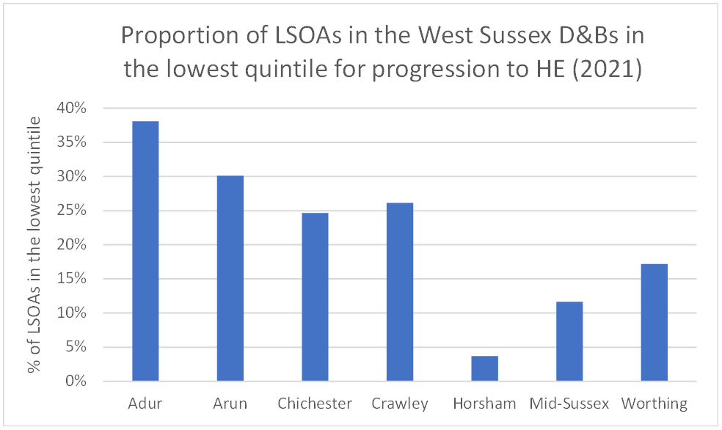
Pupil absence (PHOF data)

Over the last ten years, pupil absence (both authorised and unauthorised) has decreased and, in the last 5 years, has fluctuated around 4.6%, in line with England; in 2018/19, 4.68% of half day sessions were missed by pupils.
31 March 2021
13:58

SOCIAL CONTEXT (from LAIT)
In 2020:
10.2% of primary school-aged children (incl. nursery) were eligible for FSM (England = 17.7%)
8.9% of secondary school-aged children were eligible for FSM (England = 15.9%)

12.1% of primary school-aged children had a first language other than English (England = 21.3%)
9.5% of secondary school-aged children had a first language other than English (England = 17.1%).

Why is this subject important for health and wellbeing?
This is a key measure of early years development across a wide range of developmental areas. Children from poorer backgrounds are more at risk of poorer development and the evidence shows that differences by social background emerge early in life.

Learning ensures that children develop the knowledge and understanding, skills, capabilities and attributes that they need for mental, emotional, social and physical wellbeing now and in the future.
Children with poorer mental health are more likely to have lower educational attainment and there is some evidence to suggest that the highest level of educational qualifications is a significant predictor of wellbeing in adult life; educational qualifications are a determinant of an individual's labour market position, which in turn influences income, housing and other material resources. Educational attainment is influenced by both the quality of education children receive and their family socio-economic circumstances.
Children's education and development of skills are important for their own wellbeing and for that of the nation as a whole.
Learning ensures that children develop the knowledge and understanding, skills, capabilities and attributes that they need for mental, emotional, social and physical wellbeing now and in the future.
Children with poorer mental health are more likely to have lower educational attainment and there is some evidence to suggest that the highest level of educational qualifications is a significant predictor of wellbeing in adult life; educational qualifications are a determinant of an individual's labour market position, which in turn influences income, housing and other material resources. Educational attainment is influenced by both the quality of education children receive and their family socio-economic circumstances.

SEND (DfE data)

In 2020/2021, there were 4732 pupils with a statement of special educational needs (SEN) or an Education, Health and Care (EHC) attending a West Sussex school. This represents 3.7% of all pupils and is similar to the South East region and England.

18,175 pupils received SEN support and did not have a statement of SEN or an EHC plan. This represents 14.2% of all pupils and is slightly greater than the South East region and England (12.2% of pupils).

School pupils with social, emotional and mental health needs: % of school pupils with social, emotional and mental health needs (School age)

From <https://fingertips.phe.org.uk/profile-group/mental-health/profile/cypmh/data#page/4/gid/1938133090/pat/6/par/E12000008/ati/102/are/E10000032/iid/91871/age/217/sex/4/cid/4/tbm/1/page-options/car-do-0>

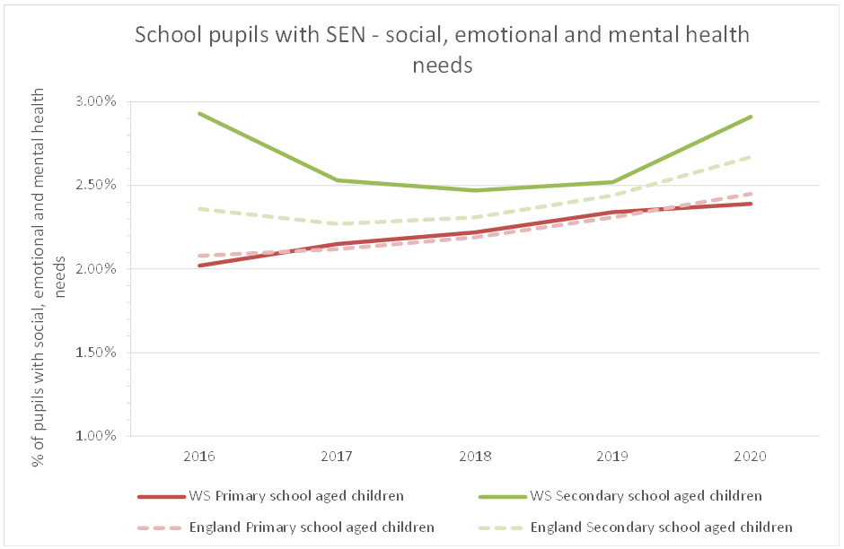

Are some people more at risk than others? Does this vary across areas?

Who is affected?
Families and teaching resourcing

How is it measured?
(Where possible include scale within the county)

What is the direction of travel?

Are there interventions to tackle the problem that are known to be effective? Is anything being done in West Sussex?
Also, what do we know at sub-county level, e.g. Ds&Bs, PCNs

Key reports
(PHE reports, key and recent evidence)

Sources
Also note any gaps in knowledge

NEET
31 March 2021
13:58

Why is this subject important for health and wellbeing?
Young people who are not in education, employment or training are at greater risk of a range of negative outcomes, including poor health, depression or early parenthood. The indicator is included to encourage services to work together to support young people, particularly the most vulnerable, to engage in education, training and work. The Government recognises that increasing the participation of young people in learning and employment not only makes a lasting difference to individual lives, but is also central to the Government's ambitions to improve social mobility and stimulate economic growth. To support more young people to study and gain the skills and qualifications that lead to sustainable jobs and reduce the risk of young people becoming NEET, legislation was included in 2013 to raise the participation age as contained within the Education and Skills Act 2008. This required that from 2013 all young people remain in some form of education or training until the end of the academic year in which they turn 17. From September 2016 DfE relaxed the requirement on authorities to track academic age 18-year-olds. LAs are now only required to track and submit information about young people up to the end of the academic year in which they have their 18th birthday ie academic age 16 and 17-year-olds.Statutory guidance: https://www.gov.uk/government/publications/participation-of-young-people-education-employment-and-training
Any summary relating to NEETs needs to be caveated by the high % of unknowns in West Sussex.

In the three months prior to the March 2020 lockdown, 2.3% of 16/17 year olds known to the local authority were known to be NEET (46 individuals). The activity of nearly 1 in 10 was not known during this period (193 individuals) [1]. Compared to CIPFA neighbours, West Sussex continues to have the highest proportion of 16/17 year olds who are NEET or whose status is not known [2].

[1] https://www.gov.uk/government/publications/neet-and-participation-local-authority-figures
[2] https://fingertips.phe.org.uk/search/neet#page/3/gid/1/pat/6/par/E12000008/ati/302/are/E10000032/iid/93203/age/174/sex/4/nn/nn-10-E10000032/cid/4/tbm/1/page-options/car-do-0

Who is affected?
NEETs, their dependents

Are some people more at risk than others? Does this vary across areas?
Area deprivation - variances based on policy choices and programme implementations
Socio-economic position of parents
Education and employment level of parents
Age 11 and GCSE exams levels
Learning difficulties
Offences

How is it measured?
(Where possible include scale within the county)

What is the direction of travel?
Labour Force Survey weighted estimates
% has remained mostly decreasing since 2011 with a slight increase 2020

Are there interventions to tackle the problem that are known to be effective? Is anything being done in West Sussex?
Also, what do we know at sub-county level, e.g. Ds&Bs, PCNs
Act early - PREVENTION before age 16. School leaving age is 16
you can only leave school at the age of 16 if you are continuing through to the age of 18 years old in one of the following:
- Work-based learning (e.g. you become an apprentice or find a traineeship program).
- Full-time education (e.g. at school or a college).
- Part-time education or accredited training (spending at least 20 hours per week working or volunteering).
Tackle barriers and obstacles - address school exclusion
Work across organisational and geographical boundaries
Work with local employers
Track people and monitor progress
Base interventions on features of other successful programmes

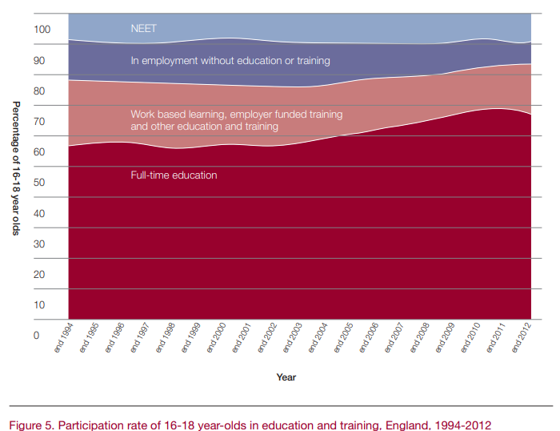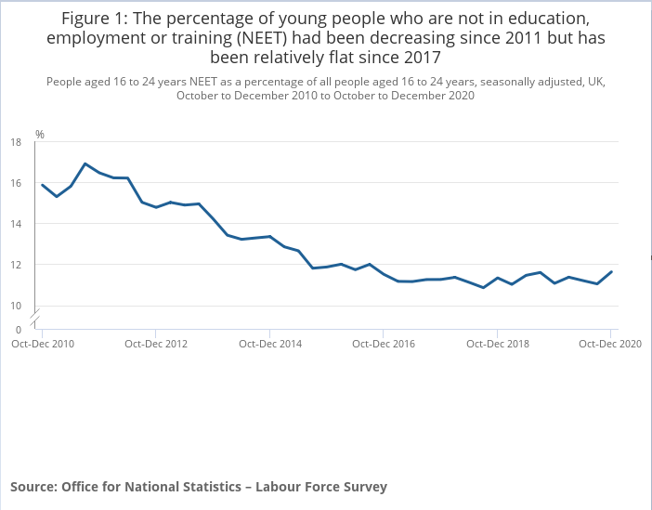

Sources
Also note any gaps in knowledge

https://www.ons.gov.uk/employmentandlabourmarket/peoplenotinwork/unemployment/bulletins/youngpeoplenotineducationemploymentortrainingneet/march2021

https://learningandwork.org.uk/wp-content/uploads/2020/04/Evidence-Review-What-works-to-support-15-to-24-year-olds-at-risk-of-becoming-NEET.pdf

https://assets.publishing.service.gov.uk/government/uploads/system/uploads/attachment_data/file/356062/Review3_NEETs_health_inequalities.pdf

https://dera.ioe.ac.uk/7999/1/Barriers%20to%20ETE%20report%20FINAL.pdf

NEET is mostly an estimate (GAP)

Key reports
(PHE reports, key and recent evidence)

Attainment of groups within population - FSM, gender, ethnicity and care leavers
31 March 2021
13:58

Why is this subject important for health and wellbeing?

Who is affected?

Are some people more at risk than others? Does this vary across areas?

How is it measured?
(Where possible include scale within the county)

What is the direction of travel?

Are there interventions to tackle the problem that are known to be effective? Is anything being done in West Sussex?
Also, what do we know at sub-county level, e.g. Ds&Bs, PCNs

Sources
Also note any gaps in knowledge

Key reports
(PHE reports, key and recent evidence)

Cultural enrichment and access to out of schools activities
31 March 2021
13:58

Why is this subject important for health and wellbeing?

Who is affected?

Are some people more at risk than others? Does this vary across areas?

How is it measured?
(Where possible include scale within the county)

What is the direction of travel?

Are there interventions to tackle the problem that are known to be effective? Is anything being done in West Sussex?
Also, what do we know at sub-county level, e.g. Ds&Bs, PCNs

Sources
Also note any gaps in knowledge

Key reports
(PHE reports, key and recent evidence)

Social care - children in need, children on CPP, re-referrals, children adopted, UASC
31 March 2021
13:58

Why is this subject important for health and wellbeing?

Who is affected?

Are some people more at risk than others? Does this vary across areas?

How is it measured?
(Where possible include scale within the county)

What is the direction of travel?

Are there interventions to tackle the problem that are known to be effective? Is anything being done in West Sussex?
Also, what do we know at sub-county level, e.g. Ds&Bs, PCNs

Sources
Also note any gaps in knowledge

Key reports
(PHE reports, key and recent evidence)

Child and YP carers
31 March 2021
13:58

Why is this subject important for health and wellbeing?

Who is affected?

Are some people more at risk than others? Does this vary across areas?

How is it measured?
(Where possible include scale within the county)

What is the direction of travel?

Are there interventions to tackle the problem that are known to be effective? Is anything being done in West Sussex?
Also, what do we know at sub-county level, e.g. Ds&Bs, PCNs

Sources
Also note any gaps in knowledge

Key reports
(PHE reports, key and recent evidence)

Criminal justice - exploitation - county lines
31 March 2021
13:58

Why is this subject important for health and wellbeing?

Who is affected?

Are some people more at risk than others? Does this vary across areas?

How is it measured?
(Where possible include scale within the county)

What is the direction of travel?

Are there interventions to tackle the problem that are known to be effective? Is anything being done in West Sussex?
Also, what do we know at sub-county level, e.g. Ds&Bs, PCNs

Sources
Also note any gaps in knowledge

Key reports
(PHE reports, key and recent evidence)

Criminal justice - YOT First Entrants
31 March 2021
13:58

Why is this subject important for health and wellbeing?

Who is affected?

Are some people more at risk than others? Does this vary across areas?

How is it measured?
(Where possible include scale within the county)

What is the direction of travel?

Are there interventions to tackle the problem that are known to be effective? Is anything being done in West Sussex?
Also, what do we know at sub-county level, e.g. Ds&Bs, PCNs

Sources
Also note any gaps in knowledge

Key reports
(PHE reports, key and recent evidence)

Planned transitions - children with disabilities, mental health, care leavers
31 March 2021
13:58

Why is this subject important for health and wellbeing?

Who is affected?

Are some people more at risk than others? Does this vary across areas?

How is it measured?
(Where possible include scale within the county)

What is the direction of travel?

Are there interventions to tackle the problem that are known to be effective? Is anything being done in West Sussex?
Also, what do we know at sub-county level, e.g. Ds&Bs, PCNs

Sources
Also note any gaps in knowledge

Key reports
(PHE reports, key and recent evidence)

